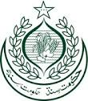 | GOVERNMENT OF SINDH  ENVIRONMENT, CLIMATE CHANGE &  COASTAL DEVELOPMENT DEPARTMENT
POSITIONS VACANT
Applications are invited from suitable candidates having domicile of Sindh for recruitment against following posts in Sindh Environmental Protection Tribunal, Environment, Climate Change & Coastal Development Department, Government of Sindh, Karachi.
Sr.No | NAME OF POSTS | TOTAL  NO. OF POSTS | URBAN | RURAL | QUALIFICATION& EXPERIENCE REQUIRED | AGE LIMIT
1. | Dispatch Rider (BPS-04) | 02 | - | 02 | - Matriculation or equivalent qualification from recognized Board of Secondary Education | 18-28
2. | Driver (BPS-04) | 04 | 01 | 03 | - Matriculation or equivalent qualification from recognized Board of Secondary Education  - Possession of valid LTV/HTV driving license  - Must be able to maintain the log book  - Having at least three (03) years experience. | 18-28
3. | Bailiff (BPS-03) | 02 | - | 02 | - Matriculation or equivalent qualification from recognized Board of Secondary Education | 18-28
4. | Daftari (BPS-02) | 01 | - | 01 | - Matriculation or equivalent qualification from recognized Board of Secondary Education | 18-28
5. | Chowkidar (BPS-01) | 02 | - | 02 | Preferably literate | 18-28
6. | Naib Qasid (BPS-01) | 06 | 02 | 04 | Middle pass | 18-28
7. | Sanitary Worker (BPS-01) | 02 | - | 02 | Preferably literate | 18-28
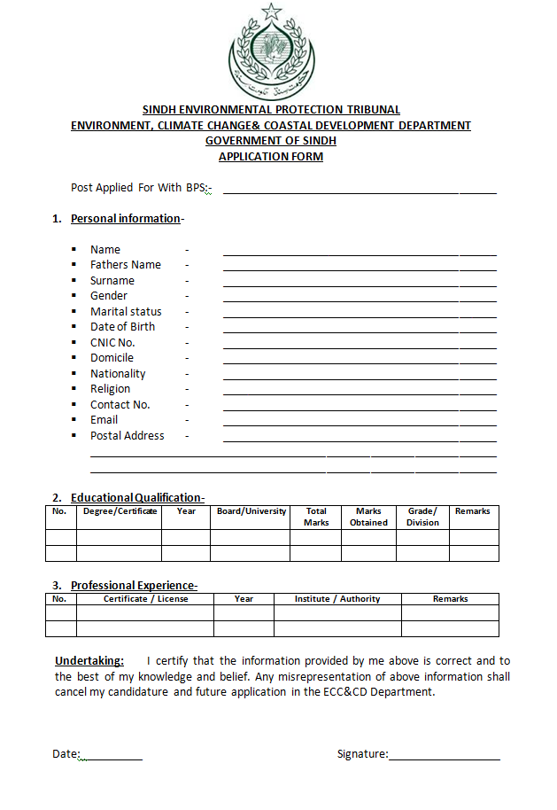
GENERAL INSTRUCTIONS:
- All candidates are required to send their duly filled applications on Prescribed Form available with this advertisement as well as on the website www.epasindh.gov.pk
- All applications should reach to the office of undersigned within 15 days of the publication of advertisement.
- Candidates applying for more than one position need to apply separately for each position.
- Incomplete or late submission of applications cannot be entertained.
- All the quota for minorities, women,differently abled persons& third gender is reserved as per Government of Sindh policy / rules.
- Candidates already in Government service should apply through proper channel.
- Age relaxation is admissible as per policy of Government of Sindh.
- Only eligible / shortlisted candidates will be called for written test or interview.
- No TA/DA will be admissible to the candidates appearing for test / interview.

Section Officer – (General)
8th Floor, State Life Building No. 01,
I.I Chandrigarh Road, Karachi

